**Deliverables:**

1. **Queries based on the designed IMDB database and its Entity:**
2. Get the list of Movies screened in Theaters of Screen type IMax and price is less than $40 for an Adult category

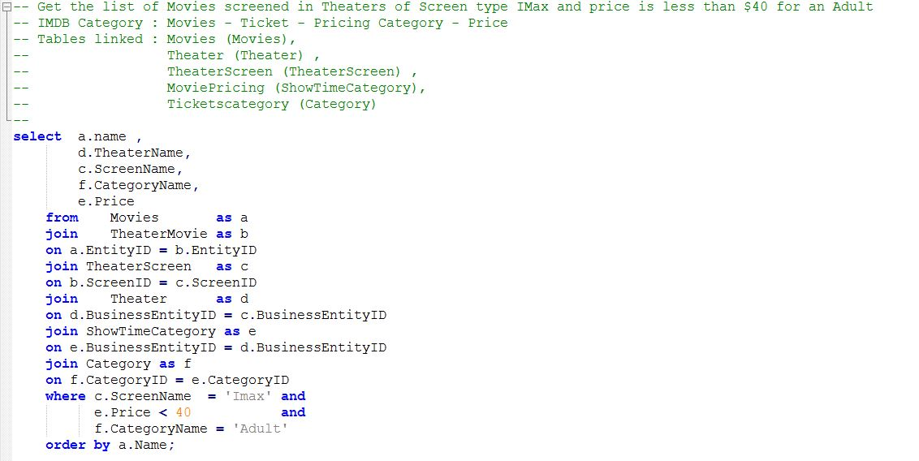

Output:

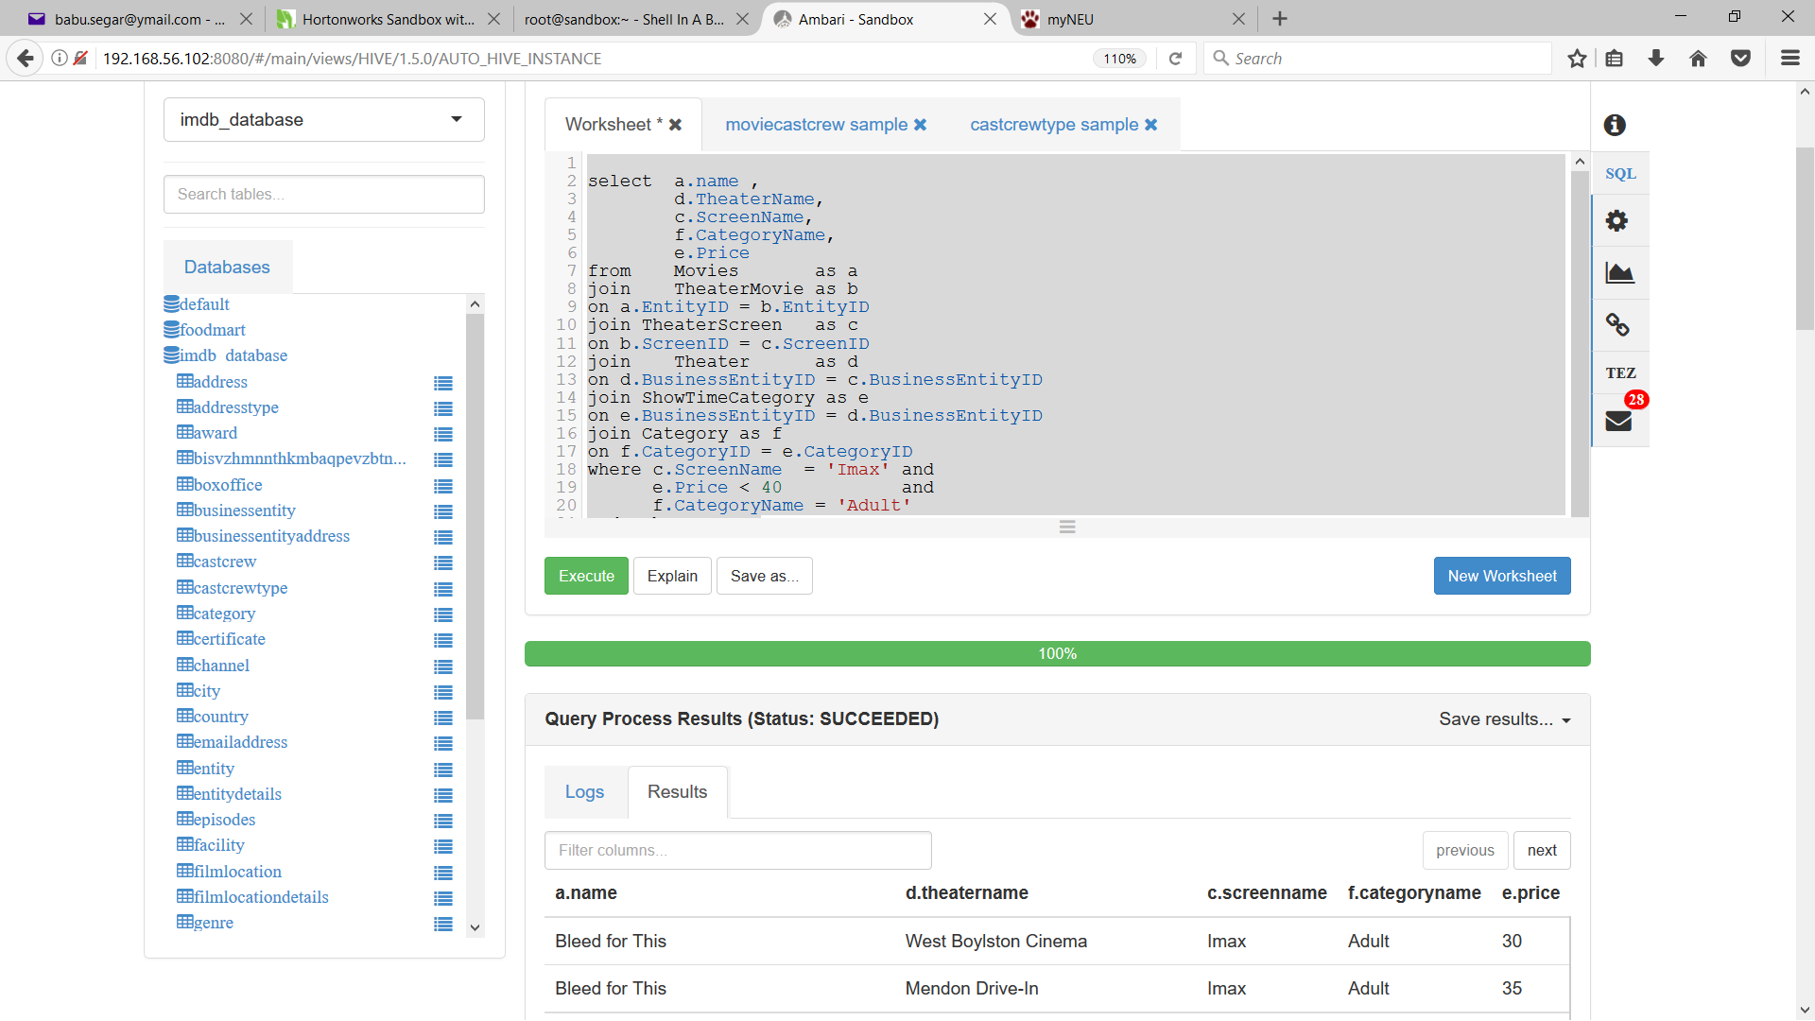

1. Get all details of the Cast and Crew - Personal details and Images (search Cast and Crew – Biographies)

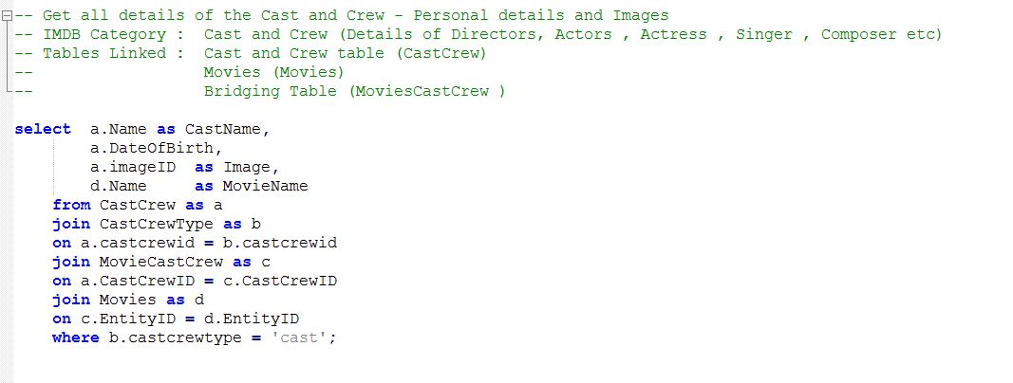

Output:

